Installation and usage for myGNSS 1.0 App

CATALOG

**1.Installation** 3

**2.SPP** 4

**2.1 Settings in SPP** 4

**2.2 Conduct SPP** 6

**2.3 View SPP Positioning Results** 8

**3.RTK** 9

**3.1 Settings in RTK** 9

**3.2 Ntrip Settings** 10

**3.3 Conduct RTK** 13

**3.4 View RTK Positioning Results** 13

**4.Record Data** 13

**4.1 Only Record GNSS Observation Data** 13

**4.2 Simultaneously Record Reference Station Data** 14

**4.3 View Recorded Data** 15

**5.Other Settings** 15

**1.Installation**

(1) Extract the program package myGNSS.zip to appropriate directory myGNSS.

(2) open the following file path: ../myGNSS/app/release, find the APK file as shown in Figure 1-1, and transfer the file to your smartphone.

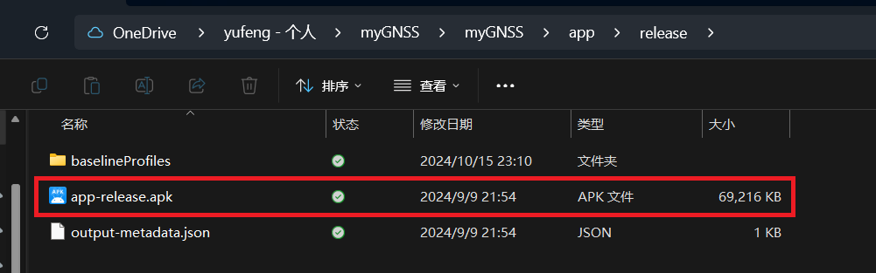

Figure 1-1 APK files

(3) Open the APK file on your smartphone and install it.

(4) After installation, open the app and you will be prompted to access the user's location information, as shown in Figure 1-2. Click the allow button

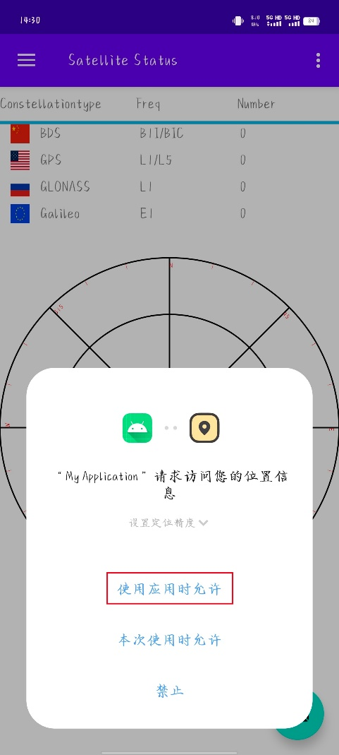

Figure 1-2 location information

(5) If you have not opened location services on your behalf, you will be prompted to open location services, as shown in Figure 1-3. Clicking YES will redirect you to the settings interface, as shown in Figure 1-4, to open location services.

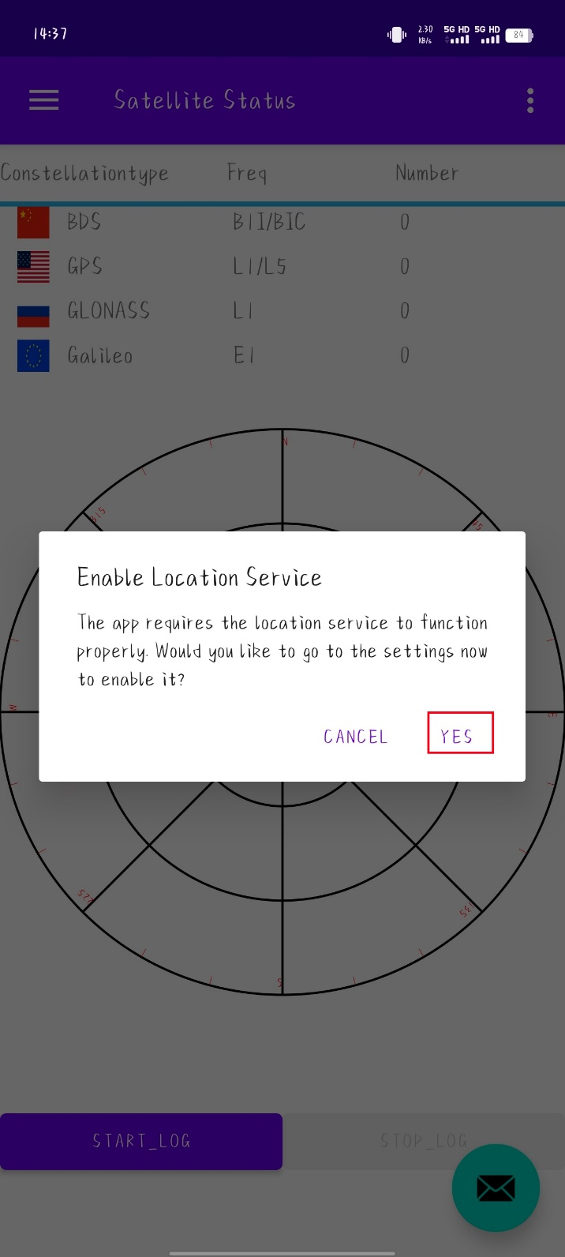

Figure 1-3 tips of enable location service

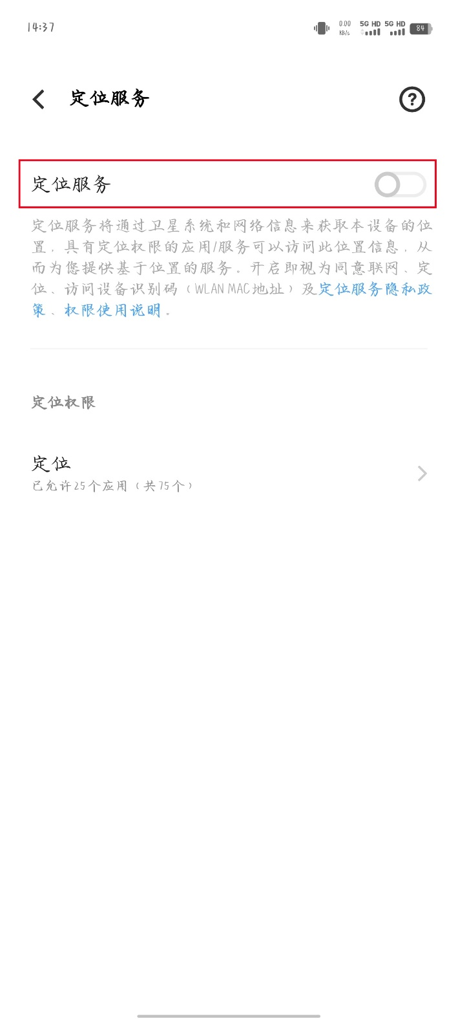

Figure 1-4 enable location service

(6) After completing all settings, you can go to the main interface, as shown in Figure 1-5.

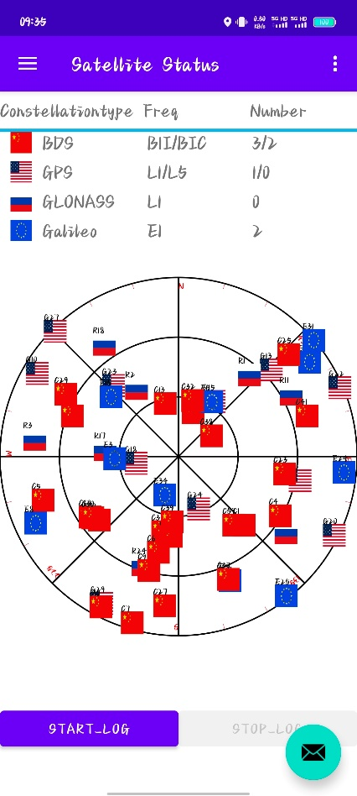

Figure 1-5 main interface

**2.SPP**

**2.1 Settings in SPP**

(1) Open the app and click the menu button in the upper left corner as shown in Figure 2-1 to open the menu.

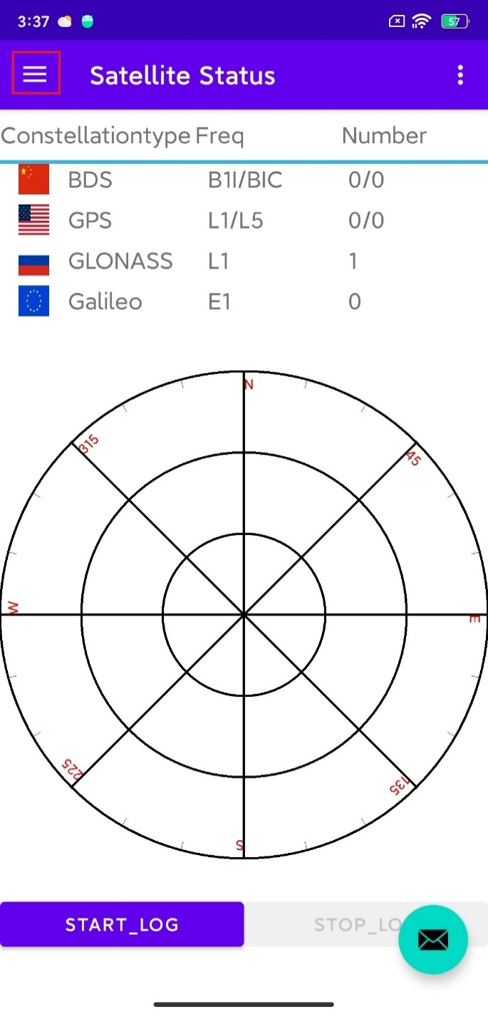

Figure 2-1 menu button

(2) Select the settings button as shown in Figure 2-2 and open the settings interface.

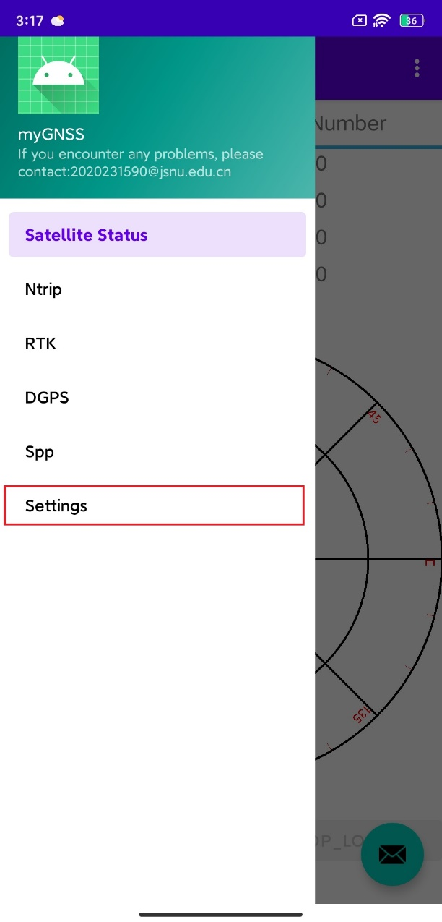

Figure 2-2 open settings interface

(3) The settings interface is mainly divided into three parts, the first of which is the solution settings as shown in Figure 2-3. It mainly includes ionospheric models, troposphere models, cut-off angles, carrier to noise ratio thresholds, frequencies, and GNSS systems (Suggest using GPS, development of other options is not yet complete). You can set it according to your own needs.

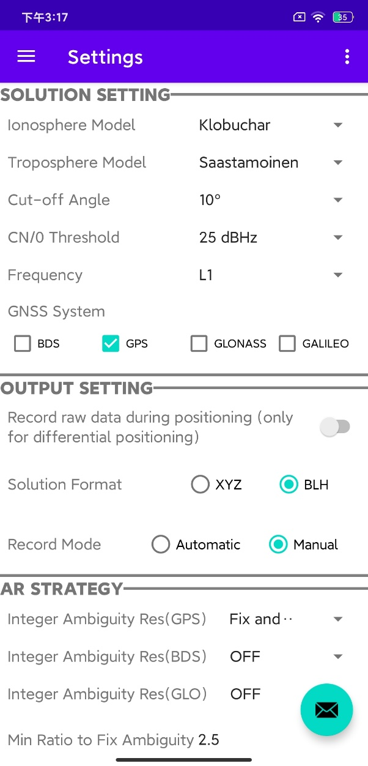

Figure 2-3 solution settings

(4) The second part is the output settings, as shown in Figure 2-4, which mainly includes the recording of base station data during differential positioning, the selection of file format and recording mode for output results. You can set it according to your own needs.

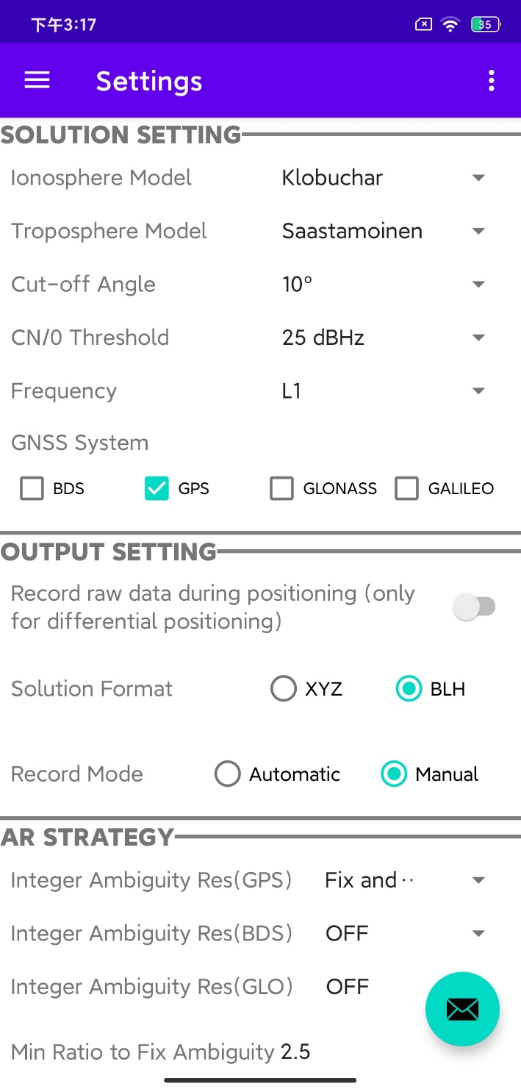

Figure 2-4 output setting

(5) The third part is the ambiguity resolution strategy, as shown in Figure 2-5 which can be omitted as it is SPP. After setting up, click the save button.

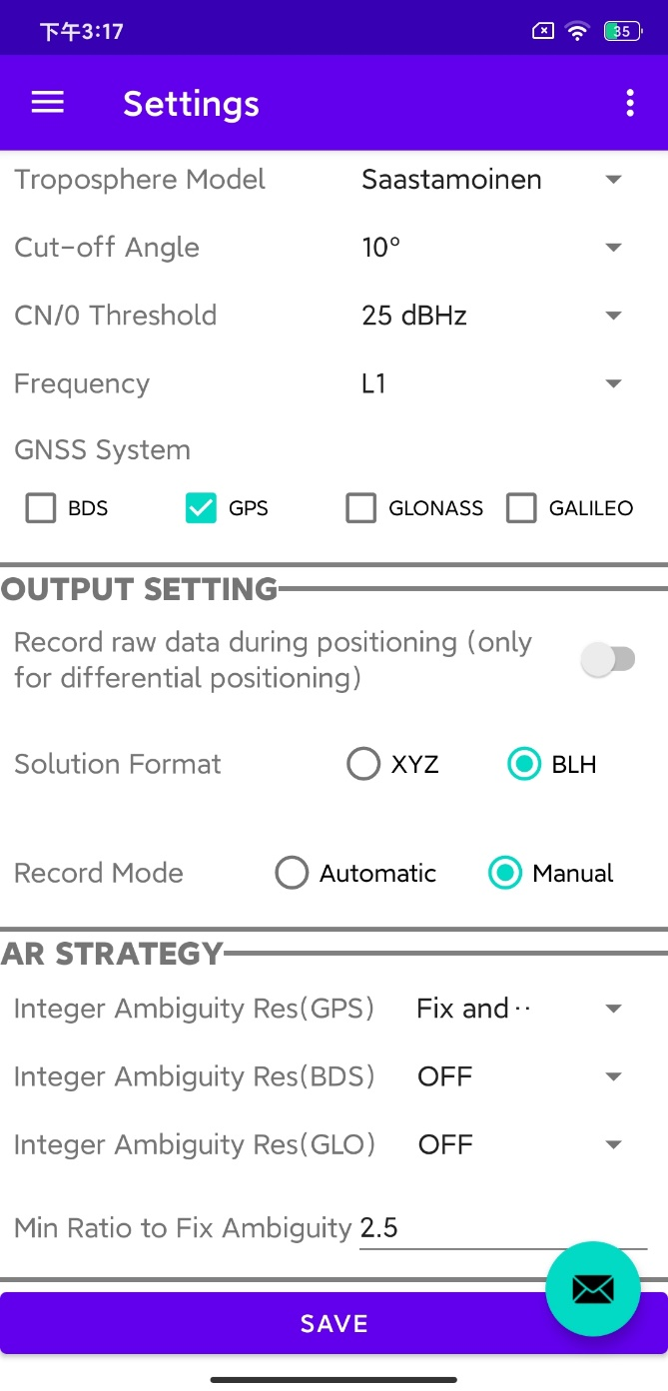

Figure 2-5 AR strategy

**2.2 Conduct SPP**

(1) After completing the settings, exit the settings interface, click the menu button, and select SPP as shown in Figure 2-6 to open the SPP interface.

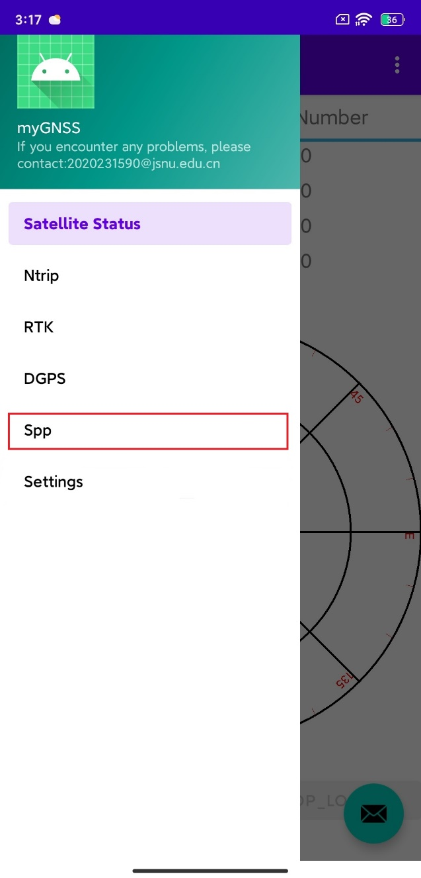

Figure 2-6 turn to SPP interface

(2) The opened SPP interface is shown in Figure 2-7, and the smartphone will conduct SPP in real time.

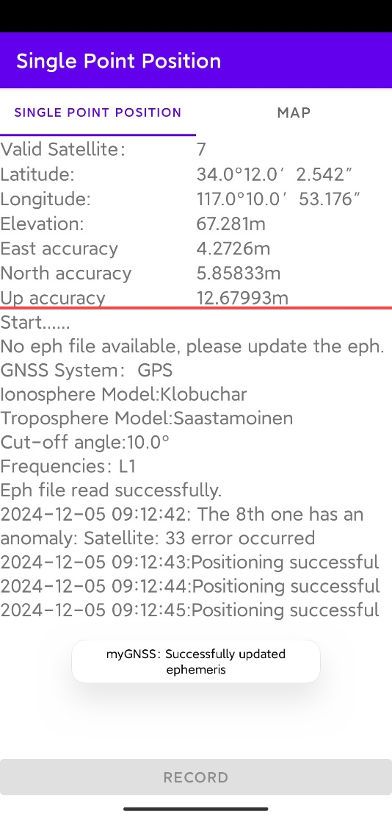

Figure 2-7 SPP interface

(3) If the recording mode in the previous output settings was set to "automatic", you can see that the button named "Record" as shown in Figure 2-8 is in a non-clickable state and will automatically record the SPP results to an ASCII text file.

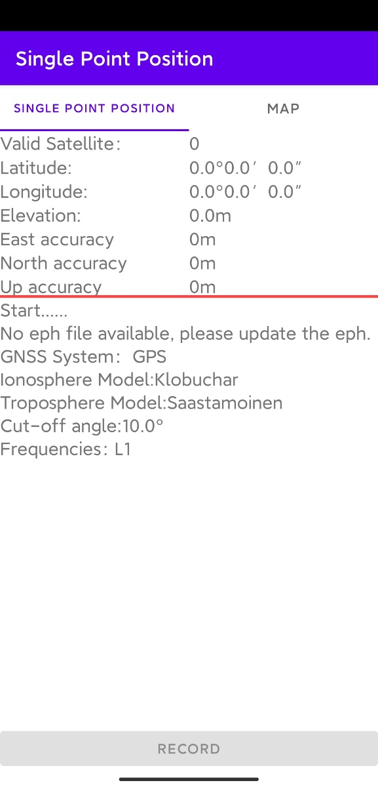

Figure 2-8 automatic record

(4) If the recording mode is "manual", you need to manually click the "record" button as shown in Figure 2-9 to save the SPP results of the current epoch to an ASCII text file.

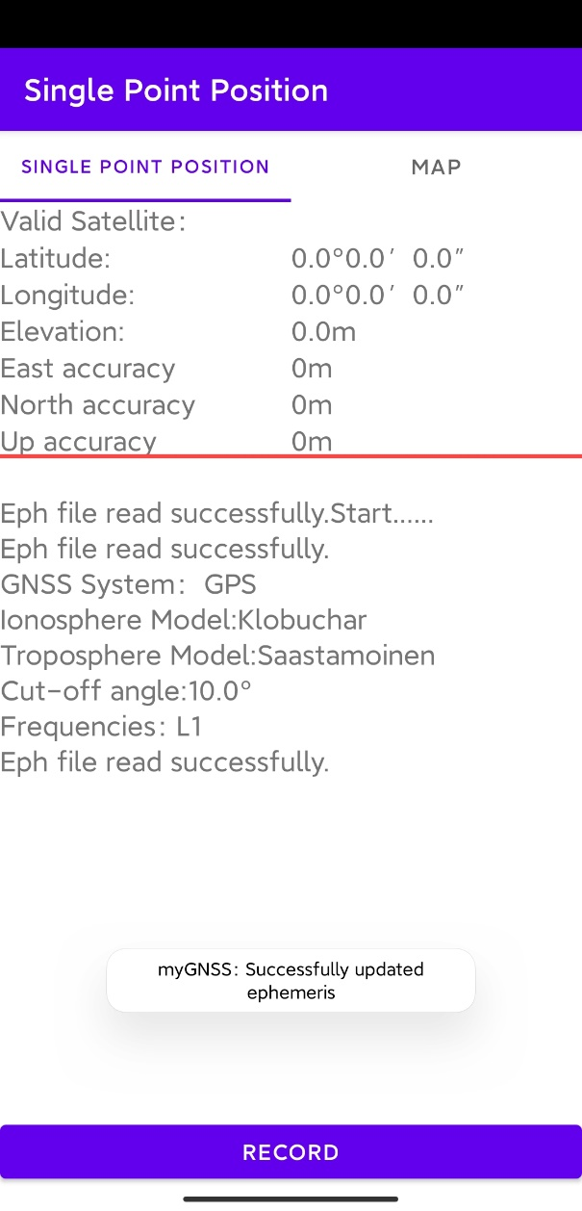

Figure 2-9 manual record

(5) You can click on the "Map" option as shown in Figure 2-10 to view the current location displayed in the SPP results.

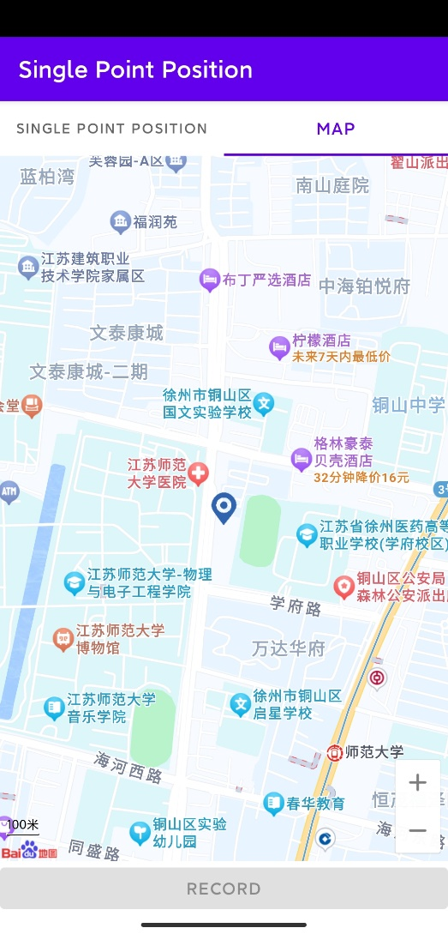

Figure 2-10 map

**2.3 View SPP Positioning Results**

(1) After SPP ends, exit to the main interface and click the floating button of the envelope pattern as shown in Figure 2-11.

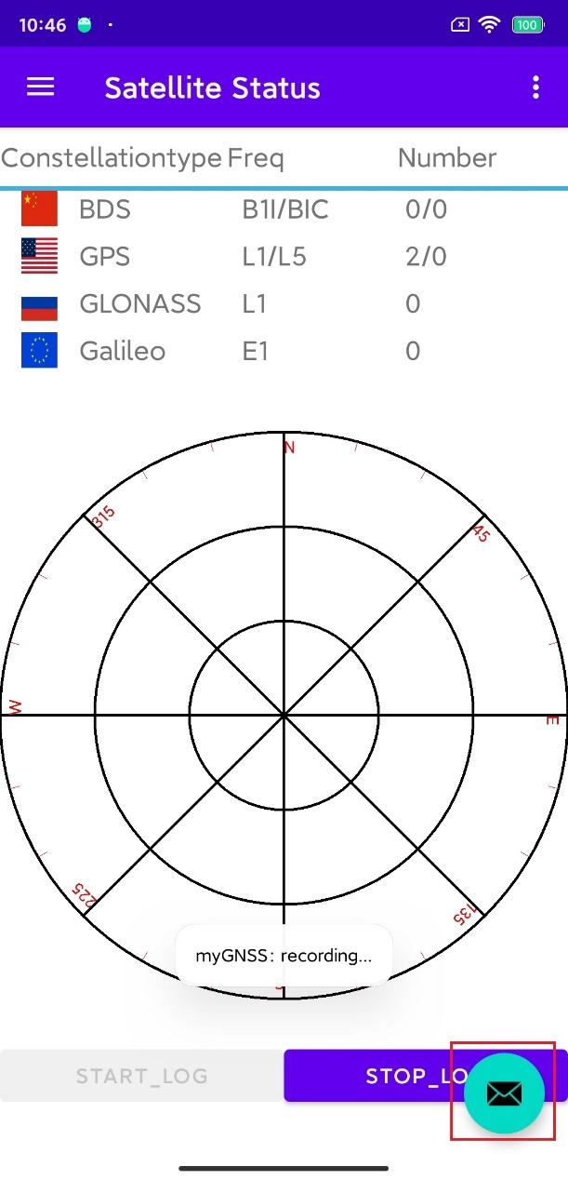

2-11 floating button

(2) After clicking the button, an interface will pop up as shown in Figure 2-12. There are two options in this interface. We choose the first option to open the positioning result file and click “CONFIRM”.

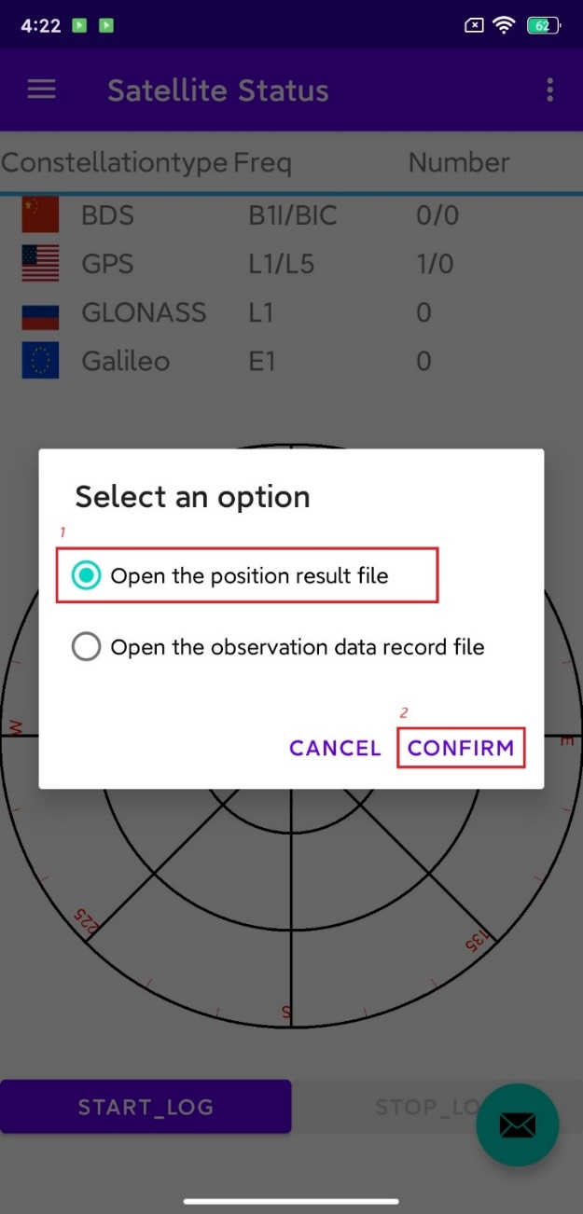

Figure 2-12 open the positioning result file

(3) Select a file manager to open, as shown in Figure 2-13. If prompted that there is no file manager, you can download it yourself. In this example, the ES file manager is used. If none of the above methods work, you can check the following path: /storage/emulated/0/Android/data/com.example. myapplication/files/MyGnss.

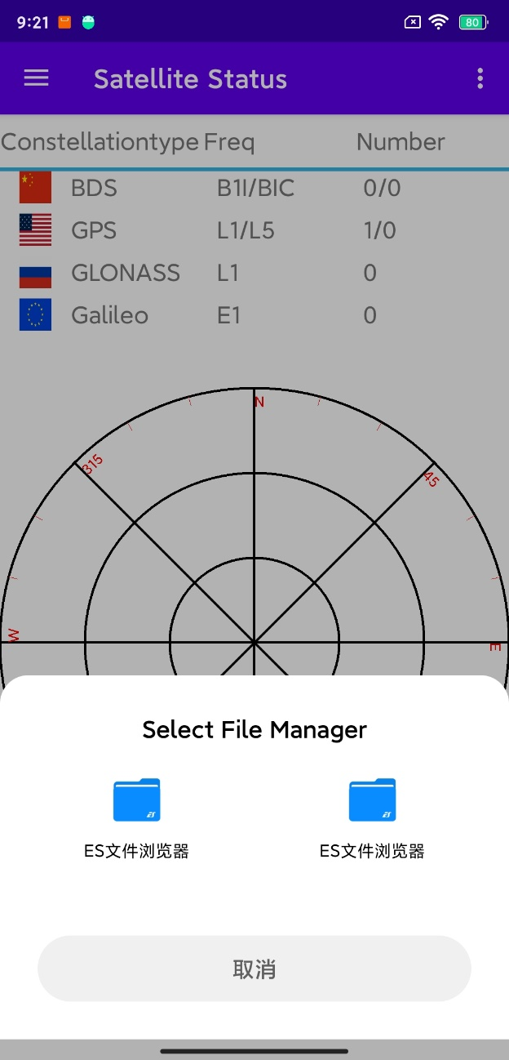

Figure 2-13 Select a file manager

(4) Next, you can select the corresponding positioning result file to open, as shown in Figure 2-14.

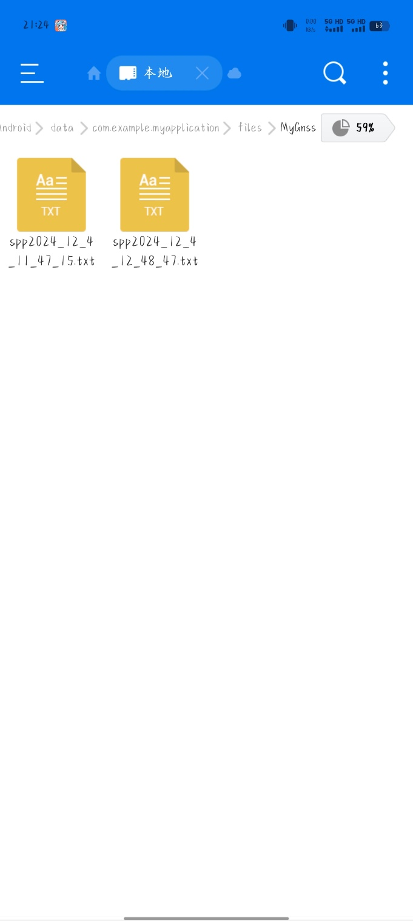

Figure 2-14 result files

**3.RTK**

**3.1 Settings in RTK**

(1) Open the app and click the menu button in the upper left corner as shown in Figure 2-1 to open the menu.



Figure 3-1 menu button

(2) Select the settings button as shown in Figure 2-2 and open the settings interface.



Figure 3-2 open settings interface

(3) The solution and output setting in the settings can refer to the SPP settings mentioned earlier. Here, we mainly explain the AR strategy, as shown in Figure 3-3.



Figure 3-3 AR strategy

(4) The AR strategy mainly includes three GNSS satellite systems, namely GPS, BDS, and GLO. Click on the GPS dropdown menu to select different strategies according to your needs, as shown in Figure 3-4. In addition, a minimum threshold can be set for fix ambiguity.

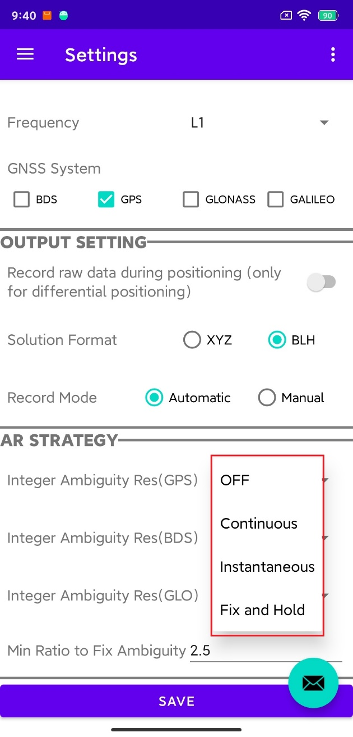

Figure 3-4 AR strategy of GPS

**3.2 Ntrip Settings**

(1) Return to the main interface, click on the menu, select Ntrip, and connect to CORS station, as shown in figure 3-5.

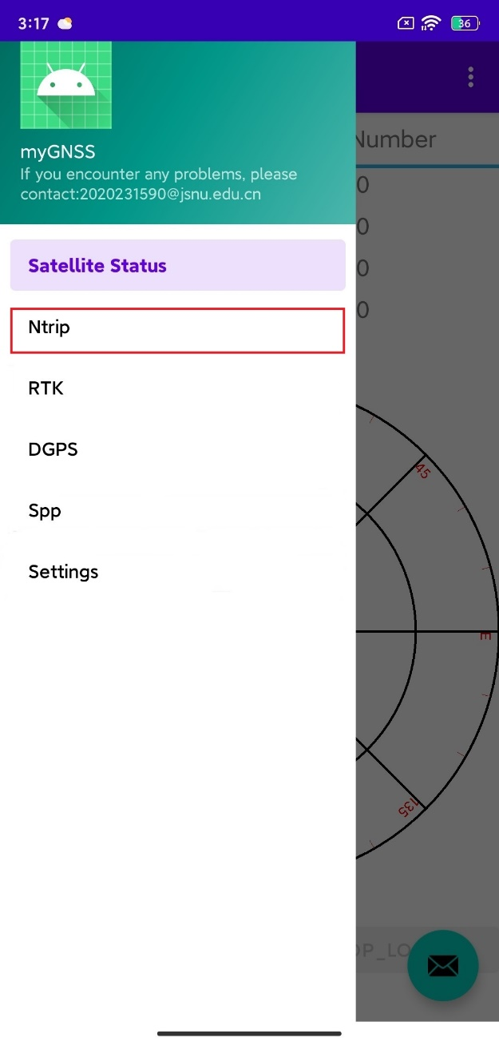

figure 3-5 trun to ntrip setting

(2) Figure 3-6 shows the Ntrip settings interface, which mainly includes "launch", "Data Source Settings", and "GGA Settings"

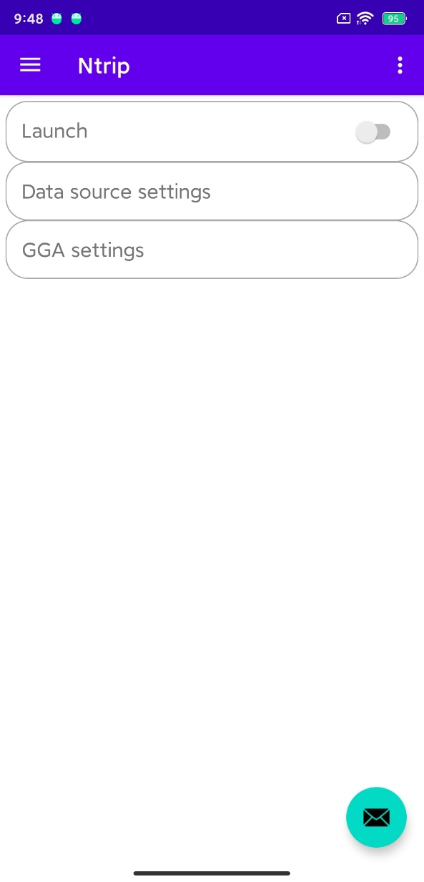

Figure 3-6 Ntrip settings interface

(3) We first click on "Data Source Settings", and an interface will pop up as shown in Figure 3-7. We need to purchase an account from CORS company and fill in the "IP address", "port", "mount point", "account", and "password" in sequence. After filling it out, click OK

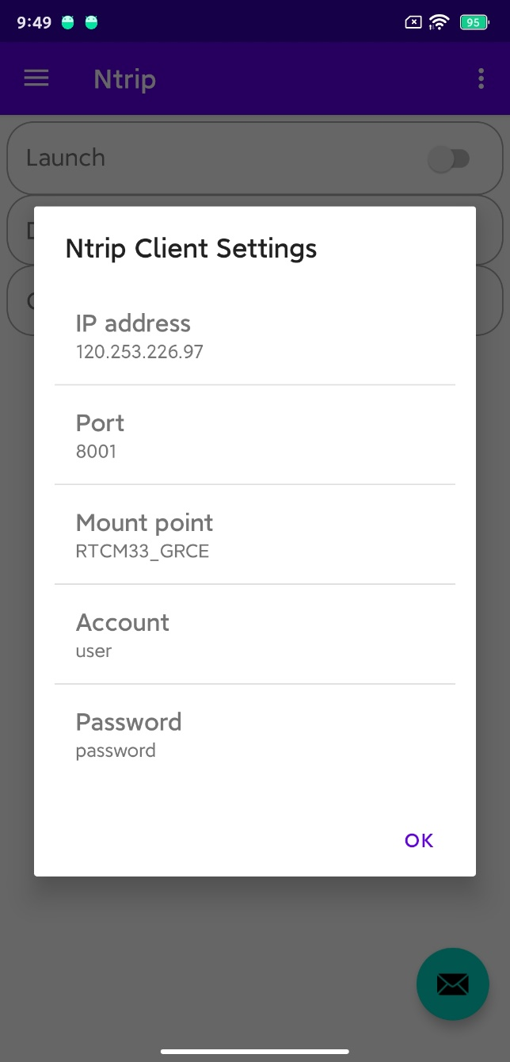

Figure 3-7 data source settings

(4) Then we click on "GGA Settings", and an interface will pop up as shown in Figure 3-8. There are two options in total, namely "Database" and "Enter BLH".

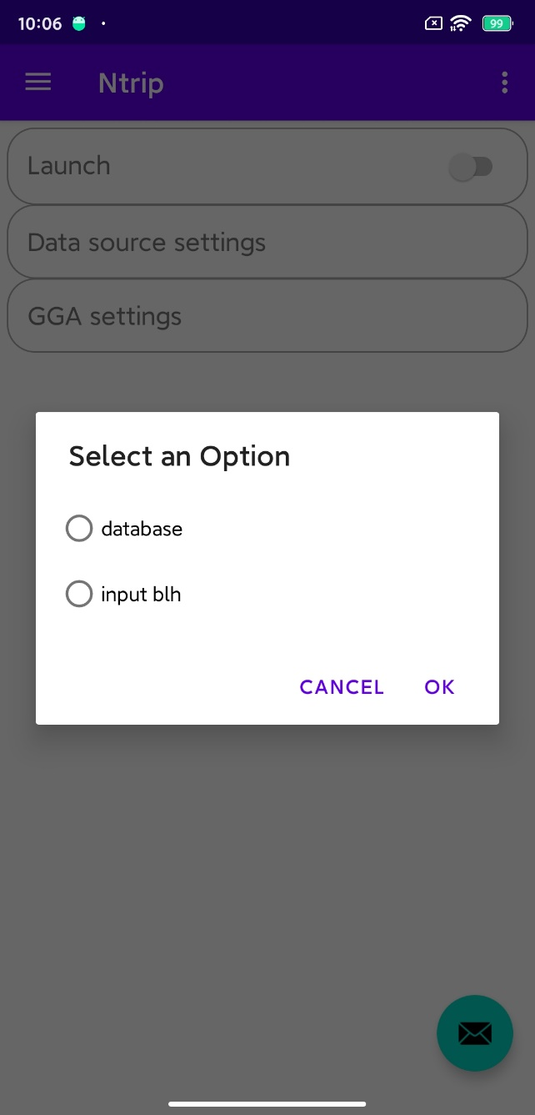

Figure 3-8 GGA Settings

(5) If you choose "Database", you will select the location information of the most recent database save. If you encounter a situation as shown in Figure 3-9 where there is no position data, you can first perform SPP to roughly locate and these location results will be automatically saved to the database.

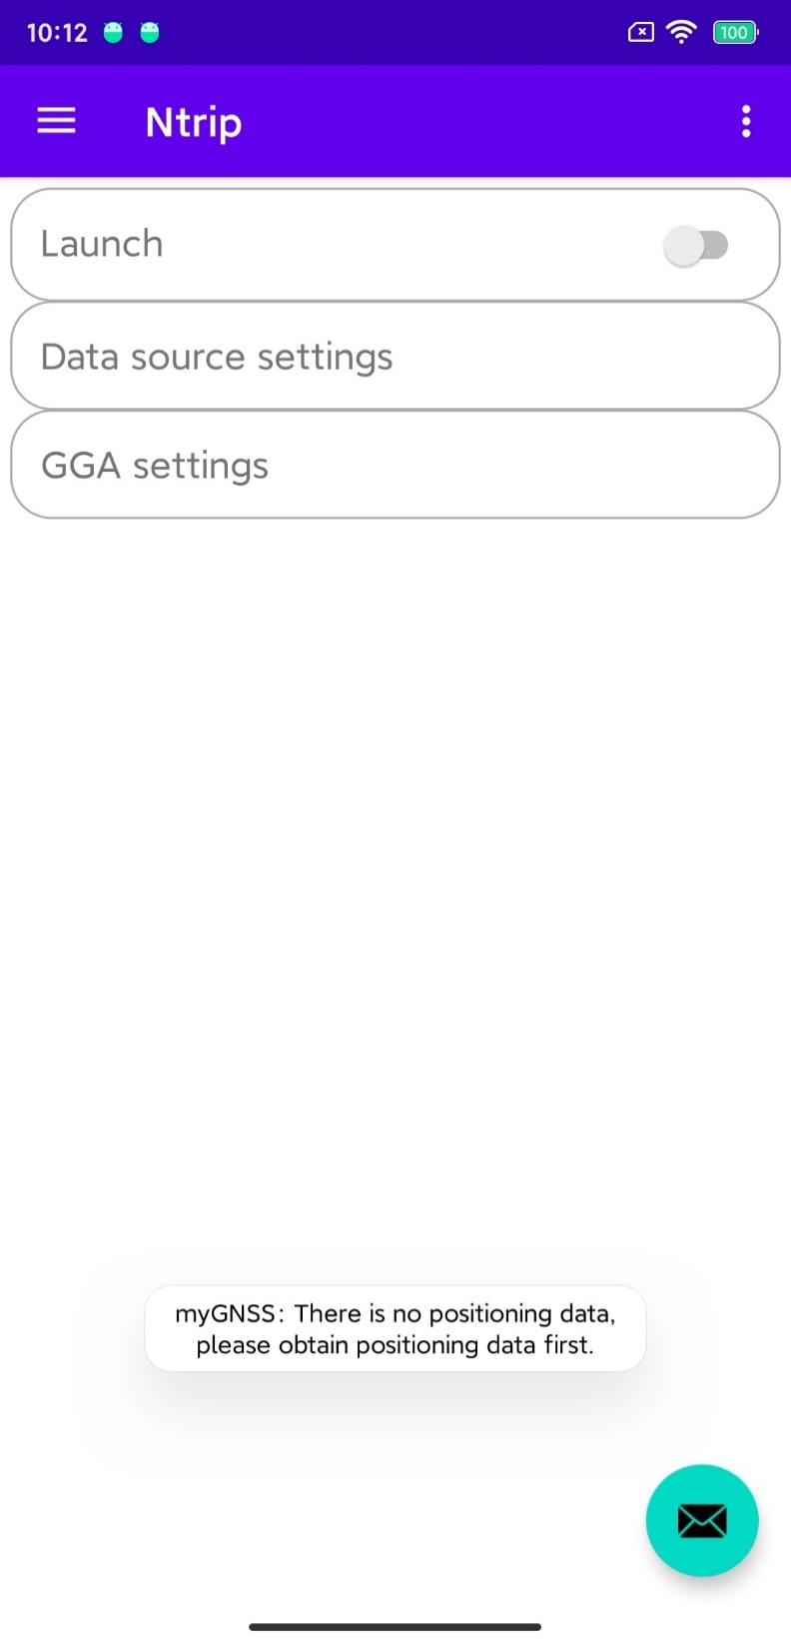

Figure 3-9 tips of no position data

(6) If you choose "input blh", an interface will pop up as shown in Figure 3-10. You can manually input the current latitude and longitude information.

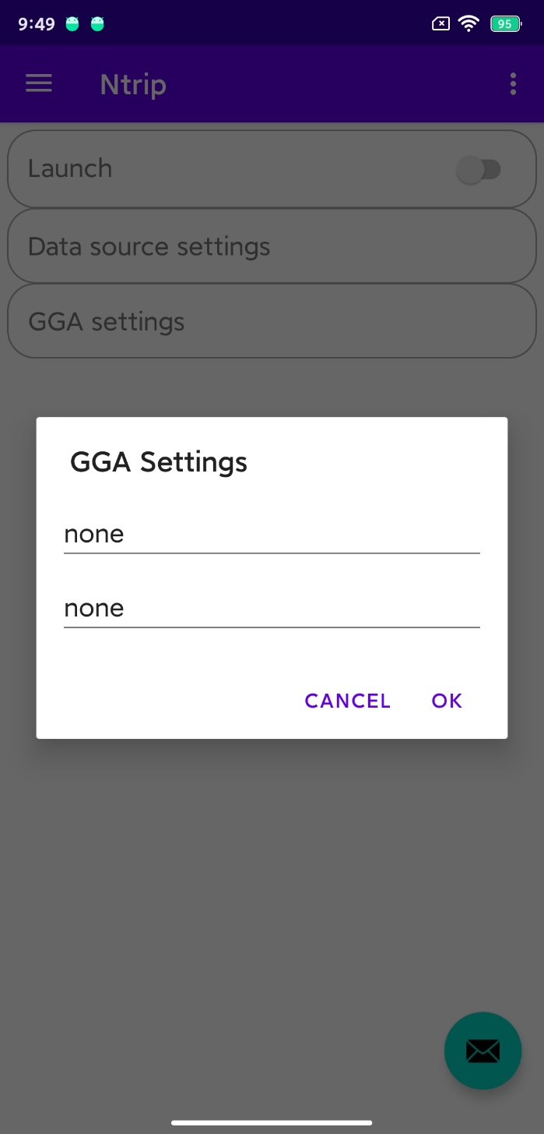

Figure 3-10 input blh

(7) After completing both "Data Source Settings" and "GGA Settings", you can click to launch. If the start is successful, a message box will pop up, and the "launch" button will also display the open status as shown in Figure 3-11.

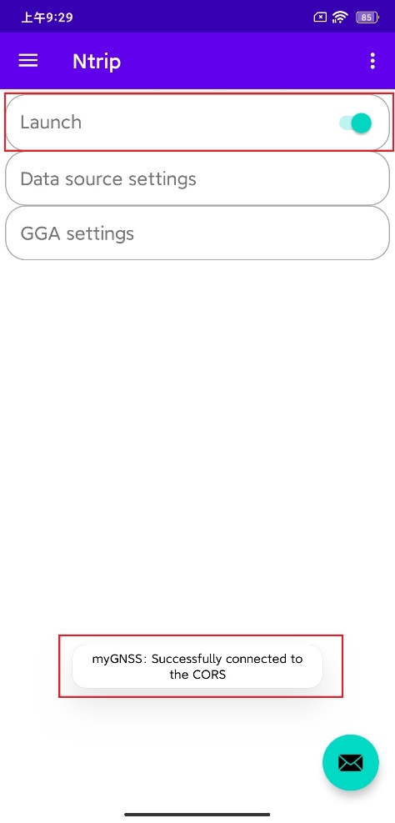

Figure 3-11 connect successfully

**3.3 Conduct RTK**

(1) After both CORS station and settings are set up, RTK can be conducted, as shown in figure 3-12.

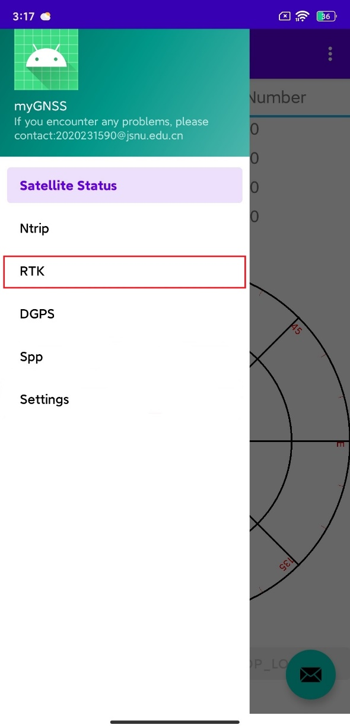

Figure 3-12 turn to RTK interface

(2) The RTK interface is shown in Figure 3-13, and the smartphone will conduct RTK in real time.

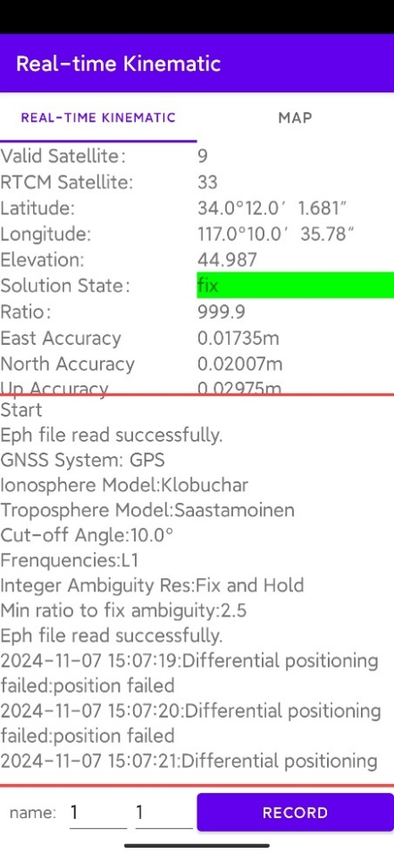

Figure 3-13 RTK interface

(3) If the recording mode in the previous output settings was set to "automatic", you can see that the button named "Record" as shown in Figure 3-14 is in a non-clickable state and will automatically record the RTK results to a txt file.

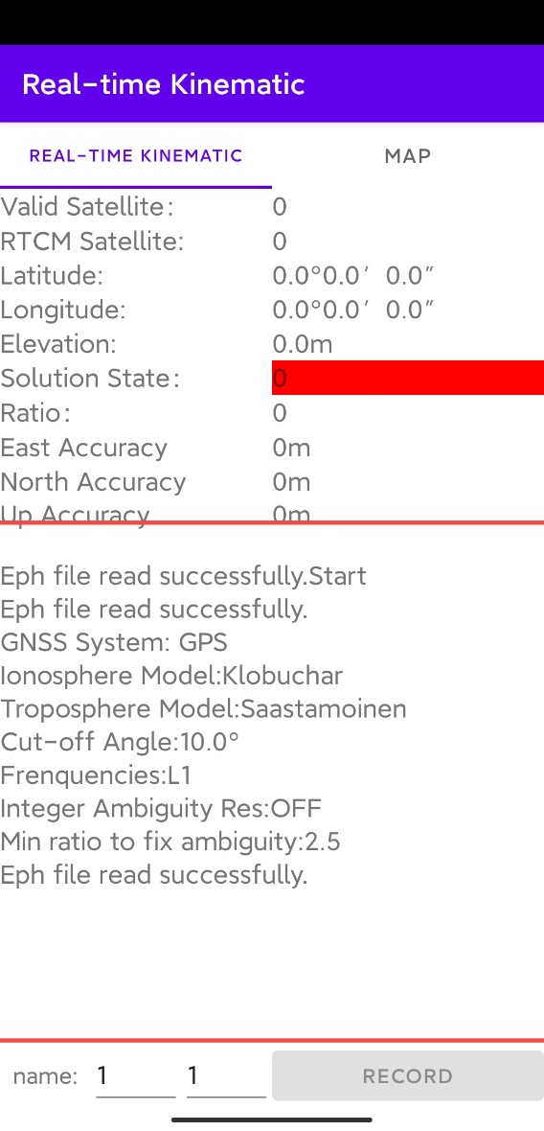

Figure 3-14 automatic record

(4) If the recording mode is "manual", you need to manually click the "record" button as shown in Figure 3-15 to save the RTK results of the current epoch to an ASCII text file. Unlike SPP, RTK allows for the definition of point names when manually recording results.



Figure 3-15 manual record

(5) You can click on the "Map" option as shown in Figure 3-16 to view the current location displayed in the RTK results.

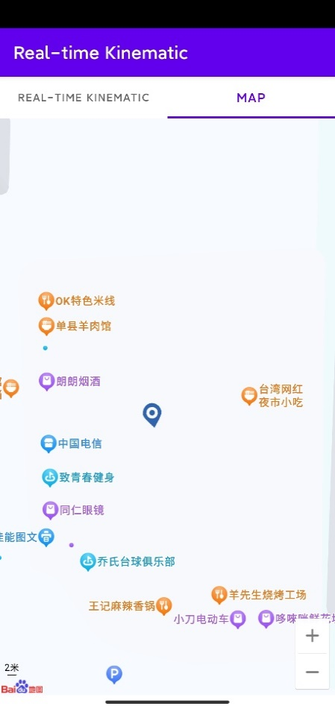

Figure 3-16 map

**3.4 View RTK Positioning Results**

(1) Please refer to section 2.3: View SPP Positioning Results

**4.Record Data**

**4.1 Only Record GNSS Observation Data**

(1) Open the main interface and click the "START_LOG" button to start recording, as shown in Figure 4-1.

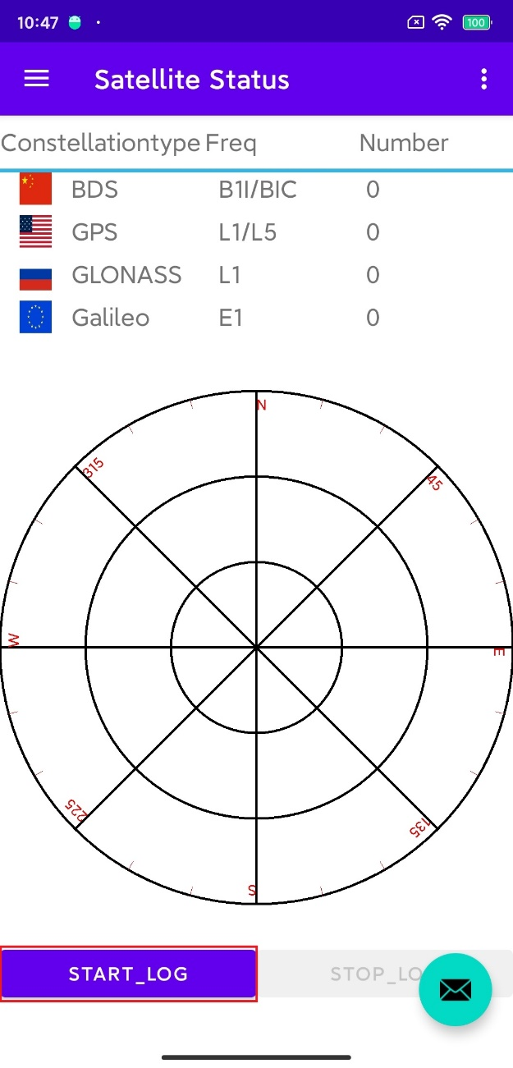

Figure 4-1 start record

(2) After clicking the button, the "START_LOG" button will become non clickable and a message box will pop up displaying the record, as shown in Figure 4-2.

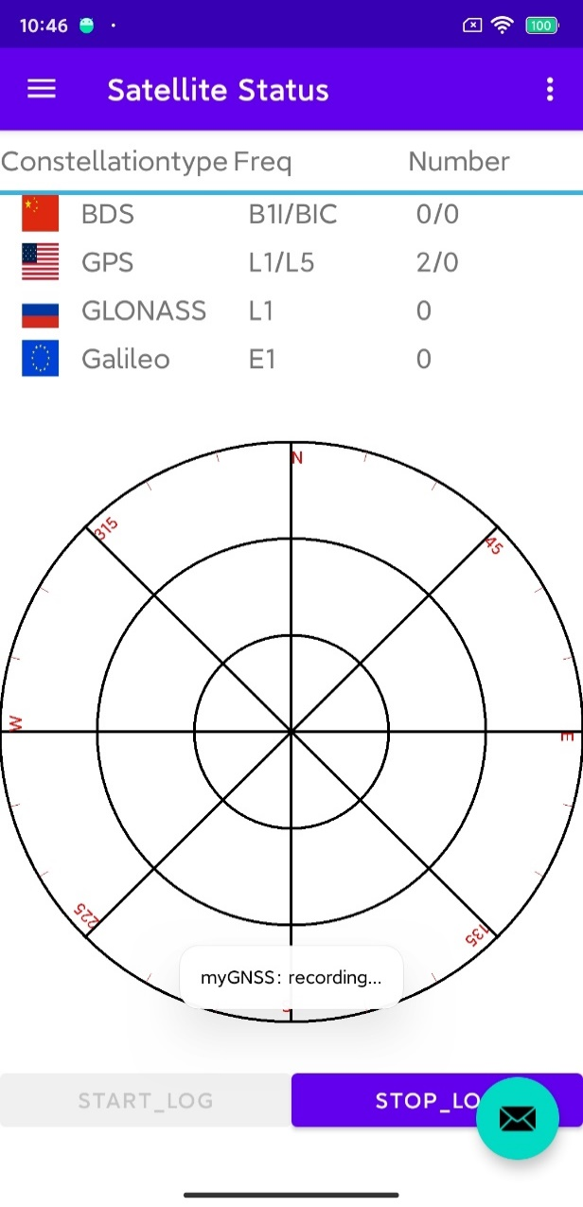

Figure 4-2 recording

(3) After completing the recording, click the "STOP_LOG" button to stop recording, as shown in Figure 4-3.

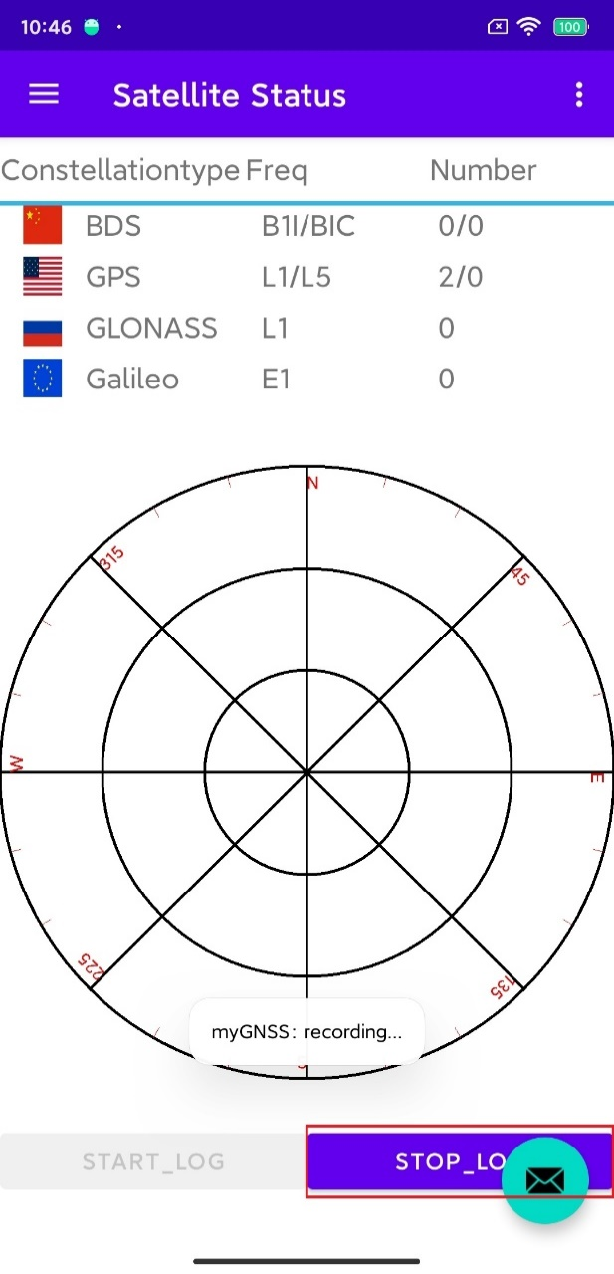

Figure 4-2 stop recording

**4.2 Simultaneously Record Reference Station Data**

(1) Open the app and click the menu button in the upper left corner as shown in Figure 4-3 to open the menu.



Figure 4-3 menu button

(2) Select the settings button as shown in Figure 4-4 and open the settings interface.



Figure 4-4 open settings interface

(3) Select the output settings section in the settings interface and open the button shown in Figure 4-5.

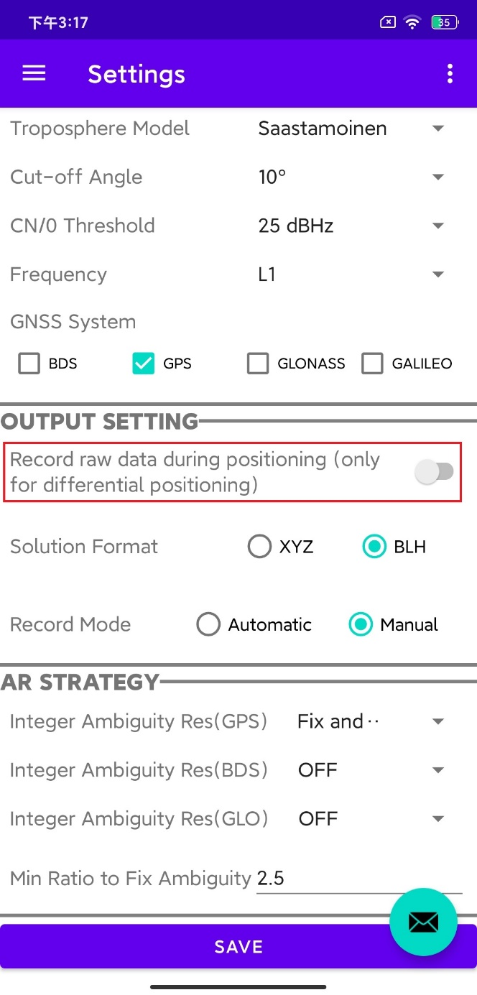

Figure 4-5 output settings

(4) Next, perform RTK according to sections 3.1 to 3.3 to simultaneously record GNSS observation data from both the smartphone and the reference station. After completing the recording, exit RTK.

**4.3 View Recorded Data**

(1) Open the main interface and click the floating button of the envelope pattern as shown in Figure 4-6.



Figure 4-6 floating button

(2) After clicking the button, an interface will pop up as shown in Figure 4-7. There are two options in this interface. We choose the second option to open the recorded observation data file and click “CONFIRM”.

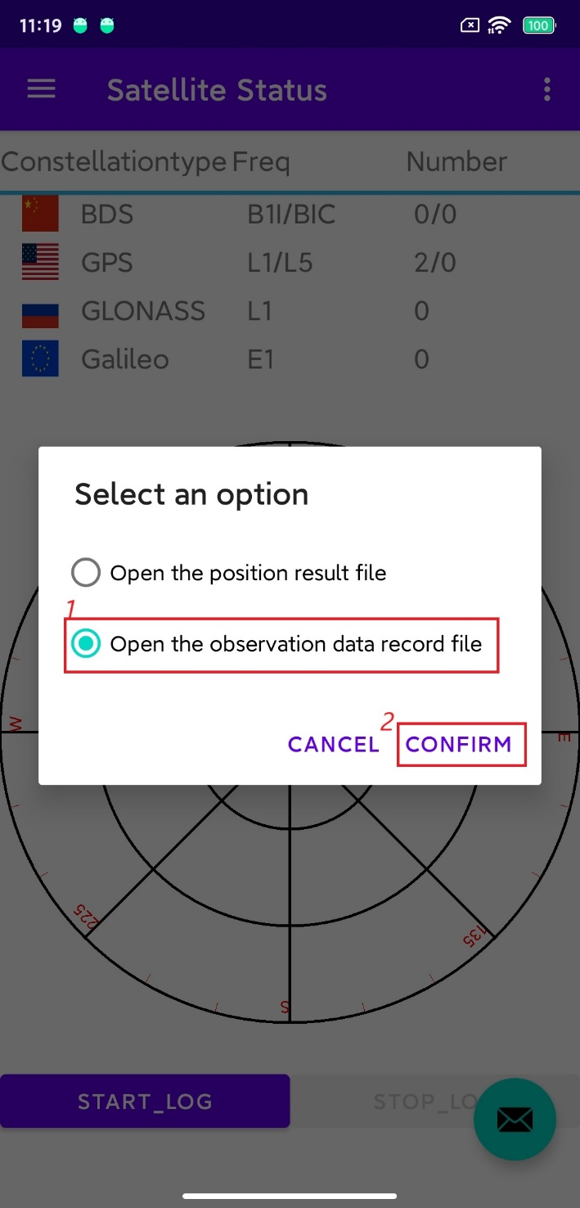

Figure 4-7 open the positioning result file

(3) Select a file manager to open, as shown in Figure 4-8. If prompted that there is no file manager, you can download it yourself. In this example, the ES file manager is used. If none of the above methods work, you can check the following path: /storage/emulated/0/Android/data/com.example. myapplication/files/MyGnss.



Figure 4-8 Select file manager

(4) Next, you can select the corresponding positioning result file to open, as shown in Figure 4-9.

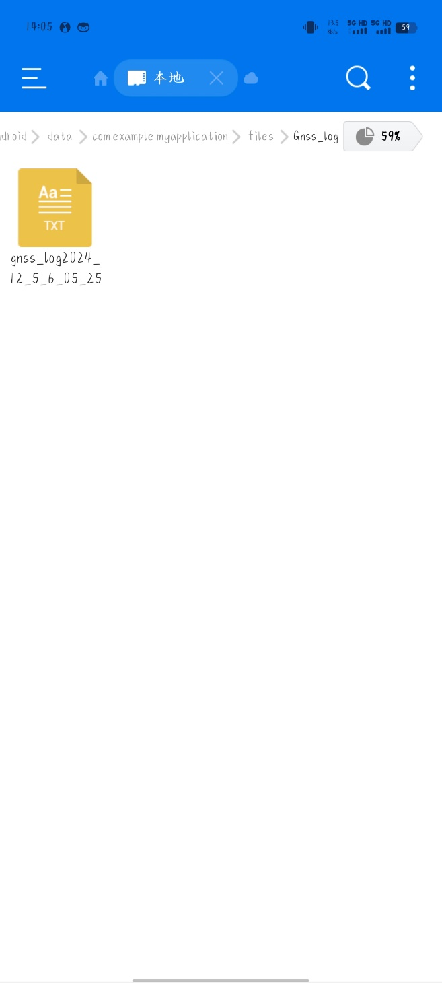

Figure 4-9 recorded files

**5.Other Settings**

(1) Open the main interface and you can see an option menu button in the upper right corner, as shown in Figure 5-1.

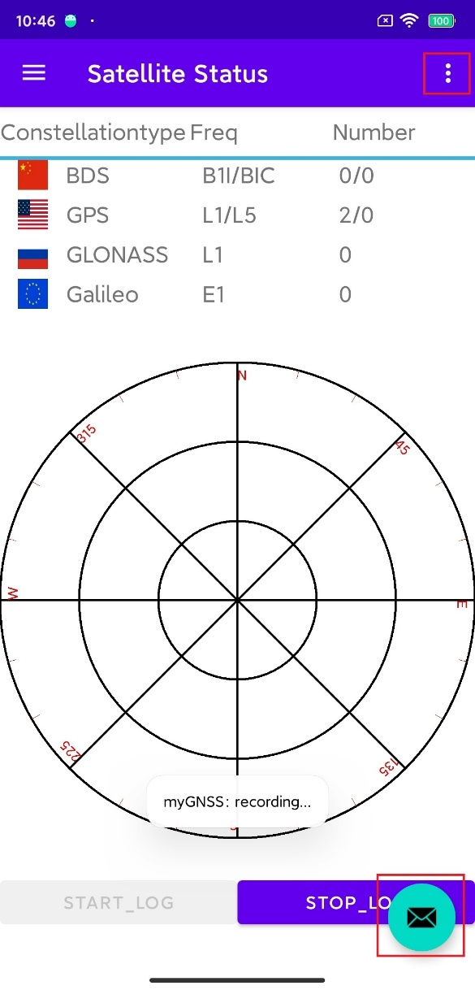

Figure 5-1 option menu button

(2) After clicking the button, a menu will pop up as shown in Figure 5-2.

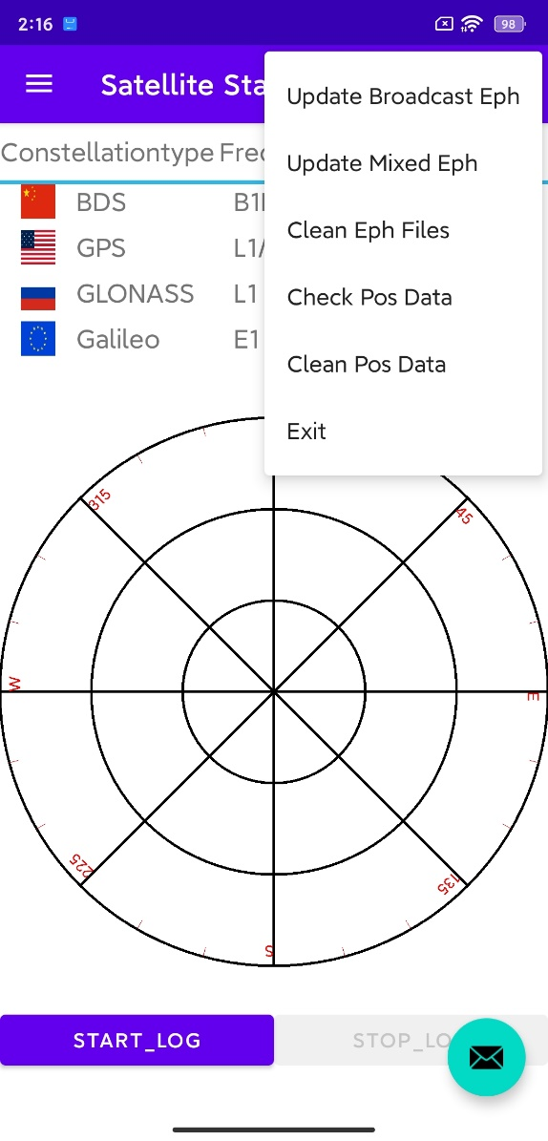

Figure 5-2 menu

(3) As shown in Figure 5-3, the first three options are about updating and deleting ephemeris. The first and second are updating broadcast ephemeris (GPS) and hybrid ephemeris, respectively. The operation of updating mixed ephemeris is currently not complete, so it is not recommended to use it. The third option is to clear the ephemeris, which will delete all downloaded ephemeris before the current day (excluding the current day).

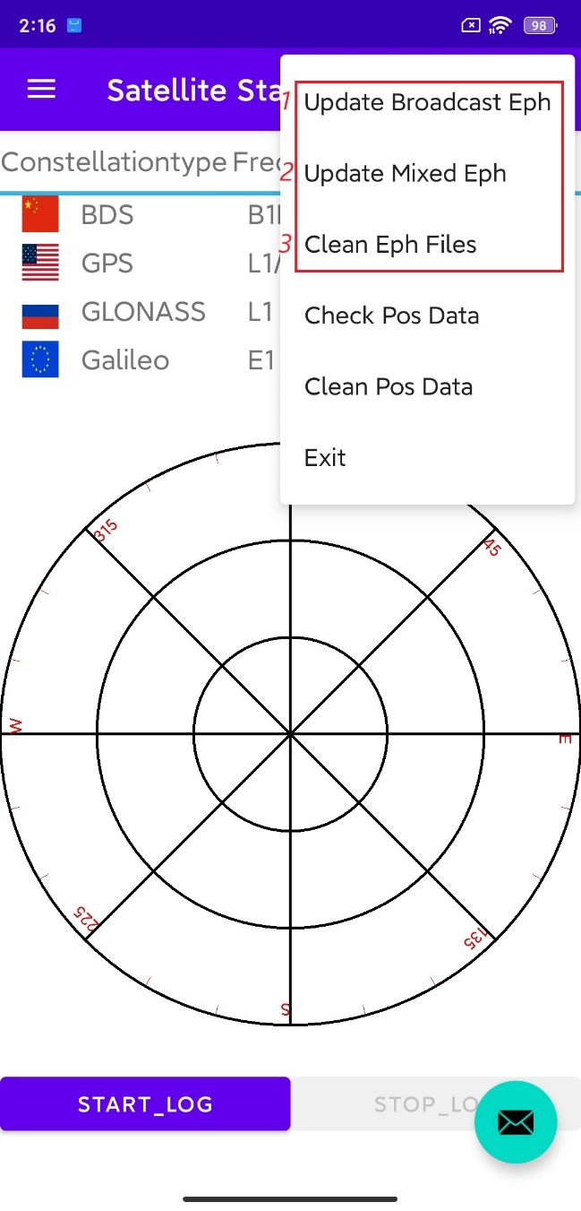

Figure 5-3 Update and deletion of ephemeris

(4) As shown in Figure 5-4, the fourth and fifth options are respectively to check and clean the database. The positioning results of SPP, RTD, and RTK will be stored in this database.

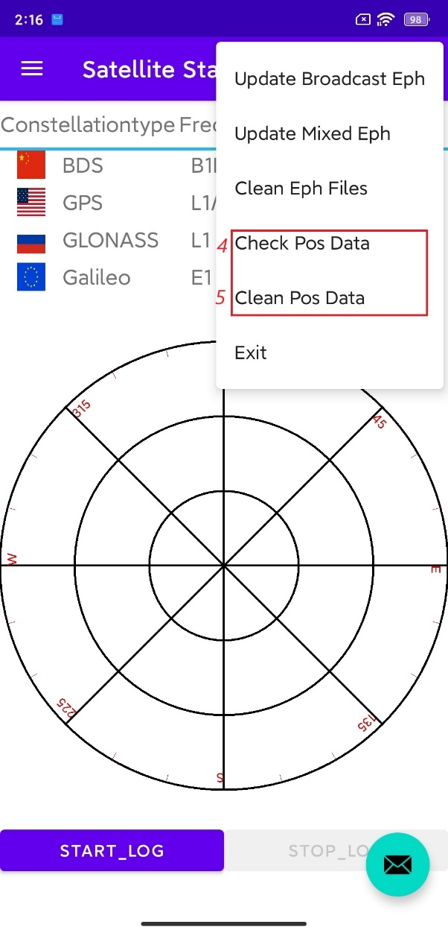

Figure 5-4 checking and cleaning databases

(5) As shown in Figure 6, the sixth option is to exit. Click on it to exit the app.

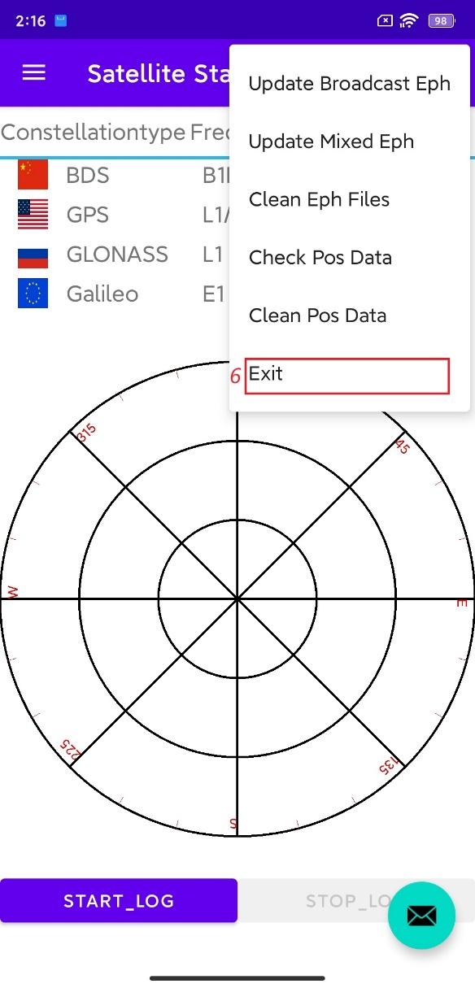

Figure 5-5 exit the app